
Prepared By: | Group Members: | Date:
Excel Group | Lebogang Molepo | Sibongile Maluleka | Tersh Kgaphola | Tshepang Mafona | Lethukuthula Mthiyane | Apr 17, 2026,

Table of Contents

Project Overview
System Architecture
Database Design
3.1 Normalization
3.2 Entity Relationship Overview
3.3 Table Schemas
ETL Pipeline
4.1 Extract Phase
4.2 Transform Phase
4.3 Load Phase
SQL Development
5.1 Key Queries
5.2 Views
5.3 Stored Procedures
Command Line Interface (CLI)
Web Application
7.1 Authentication
7.2 Role-Based Access Control
7.3 Admin Functionality
7.4 Student Functionality
Data Quality and Validation
Deployment
9.1 Database Deployment
9.2 Application Deployment
Security Considerations
Sample Data

Project Overview
The Student Record System is a relational database management solution developed to manage academic data efficiently. The system enables storage, retrieval, and management of student information, course details, enrolments, grades, and attendance records.
The project was developed in structured phases, including:
- Database design and normalization
- Synthetic data generation
- ETL pipeline development
- SQL query and procedure implementation
- Command Line Interface (CLI) development
- Web application deployment with role-based access control

The final solution is built on a three-layer architecture:
Layer | Technology | Purpose
Database | PostgreSQL (Microsoft Azure) | Persistent data storage
Backend | Python | Business logic, ETL, CLI, and API handling
Frontend | Streamlit | User interface and interaction

2. System Architecture
The system follows a three-tier architecture model, ensuring separation of concerns and scalability.
Presentation Layer
The frontend is developed using Streamlit, providing an interactive web interface. It communicates with backend modules without embedding raw SQL queries in UI components.
Application Layer
This layer handles all business logic using Python, including:
- Authentication
- Data processing and validation
- Grade calculations
- Report generation
- CLI operations

Data Layer
The PostgreSQL database, hosted on Microsoft Azure, stores all persistent data. It is fully normalized and enforces strict integrity constraints.

3. Database Design
3.1 Normalization
The database adheres to Third Normal Form (3NF):
- Each table has a primary key
- Non-key attributes depend only on the primary key
- No transitive dependencies exist

3.2 Entity Relationship Overview
Relationship | Type | Description
Students → Enrolments | One-to-Many | One student can have multiple enrolments
Courses → Enrolments | One-to-Many | One course can have multiple enrolments
Enrolments → Grades | One-to-One | Each enrolment has one grade
Enrolments → Attendance | One-to-One | Each enrolment has one attendance record

﻿
ERD of student record system

3.3 Table Schemas defines the structure of all core database tables in the Student Record System. It outlines each table’s columns, data types, and constraints to ensure data integrity and consistency across the system. The Students and Courses tables store primary academic entities, while the Enrolments table links them to represent student course registrations. Grades and Attendance tables extend the Enrolments table to track academic performance and participation, and the Users table manages authentication and role-based access for both students and administrators. Overall, this structure ensures a fully normalized relational design that supports efficient querying and reliable data management.
The upward trajectory of engagement metrics and follower count reflects the campaign's immediate impact and an overall positive audience response. The data underscores the campaign’s ability to attract new followers and keep the audience engaged. The strategies employed have resulted in stronger engagement, driving our channel growth upward.

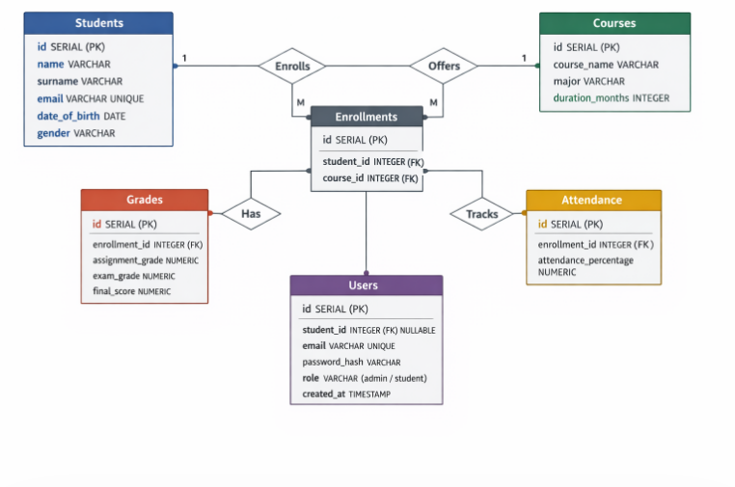

4. ETL Pipeline
The ETL pipeline automates data ingestion from CSV files into the database.

4.1 Extract Phase
Data is sourced from:
- students data.csv
- courses data.csv
- enrolments data.csv
- grades data.csv
- attendance data.csv

4.2 Transform Phase
Key transformations include:
- Handling missing values
- Standardizing formats (dates, emails, numeric values)
- Email validation
- Grade validation (0–100 range)
- Attendance validation (0–100 range)
- Duplicate record removal

4.3 Load Phase
The processed data is loaded using:
- Batch inserts for performance
- Transaction management with rollback support
- Error logging without pipeline interruption
- Timestamped logging for traceability

- SQL Development
Centralized within the queries. SQL file, the system's SQL logic facilitates comprehensive data retrieval and reporting through a series of optimized queries and views. Key operations include identifying top-performing students, generating enrolment statistics, and monitoring attendance thresholds—specifically flagging students with less than 75% attendance. To simplify complex data access, dedicated views provide instant reporting for student transcripts, course rosters, and detailed attendance summaries, ensuring that administrative data remains organized and easily accessible for academic oversight.
Beyond static reporting, the architecture utilizes robust stored procedures to manage dynamic data interactions and maintain referential integrity. These procedures automate core administrative tasks such as enrolling new students, recording individual grades, and logging daily attendance records. By encapsulating this logic within the database layer, the system ensures consistent data processing across all modules while providing a scalable framework for future academic tracking and performance analysis.
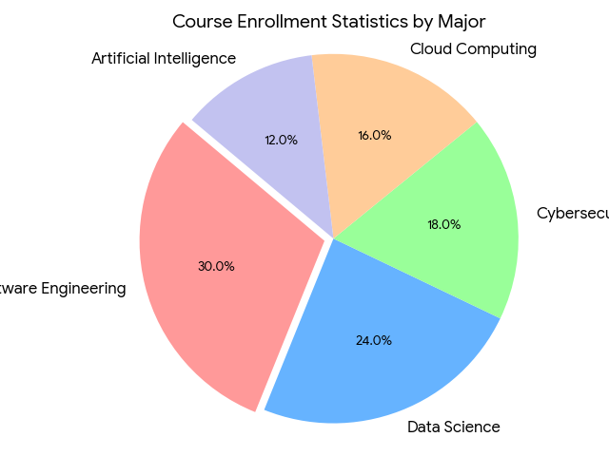

6. Command Line Interface (CLI)
The CLI provides direct interaction with the system via terminal.
Key Features:
- Add and manage student records
- Enrol students into courses
- Record grades and attendance
- Retrieve student information
- Export reports to CSV
- Input validation and robust error handling

Web Application
The system includes a fully functional web application built with Streamlit.
7.1 Authentication
- Secure login system using crypt hashing
- Session management via Streamlit session state
- Protected routes enforced via authentication checks

>>>Log in details
Admin account:
Email: admin@studentrecords.com
Password: Admin@2025

7.2 Role-Based Access Control
Role | Access
Admin | Full system access
Student | Access to personal academic records only

7.3 Admin Functionality
Admins can:
- View system metrics dashboard
- Manage students and courses
- Record grades and attendance
- Identify at-risk students
- Generate downloadable reports

7.4 Student Functionality
Students can:
- View personal dashboard
- Track grades and attendance
- Monitor academic performance

8. Data Quality and Validation
The system ensures data integrity through:
- Primary and foreign key constraints
- Unique email enforcement
- Valid grade and attendance ranges
- Secure password hashing
- Parameterized SQL queries to prevent SQL injection

9. Deployment
9.1 Database Deployment
- Hosted on Microsoft Azure PostgreSQL
- Secure connection via SSL
- Credentials managed via environment variables
Deployment link: Student Record System

9.2 Application Deployment
Component | Details
Platform | Streamlit Cloud
Repository | GitHub
Live Application | Deployed and publicly accessible
CI/CD | Automatic redeployment on code push

10. Security Considerations
Security measures include:
- No credentials stored in source code
- Password hashing using crypt
- Environment variables for sensitive data
- Role-based access enforcement
- Protection against SQL injection using parameterized queries

11. Sample Data
The system uses realistic synthetic data generated via the Faker library.
Table | Record Count
Students | 456
Courses | 25
Enrolments | 2,500
Grades | 2,500
Attendance | 2,500
Users | 457

Conclusion
The Student Record System stands as a robust integration of relational database theory and modern application design. By leveraging PostgreSQL on Azure, the project ensures high availability and data integrity through strict normalization and relational constraints. From the initial extraction phases of the ETL pipeline to the final Streamlit deployment, the architecture successfully transforms raw academic data into a functional tool for institutional oversight, secured by role-based access control and industry-standard encryption.
The transition of 2,500 records from static, fragmented CSV files into a centralized, relational environment allows for the identification of patterns that were previously inaccessible—such as the direct correlation between attendance thresholds and academic performance. This project proves that when data is properly cleaned, validated, and modelled, it ceases to be a passive storage requirement and becomes an active asset for institutional decision-making. The resulting system is not merely a record-keeping tool, but a scalable framework designed to support proactive academic intervention and data-driven administrative strategy.

